**Learning Activity 3.2: ERD Diagram**



Design a database diagram for a product orders database with four tables. Indicate the relationships between tables and identify the primary key and foreign keys in each table. Explain your design decisions.

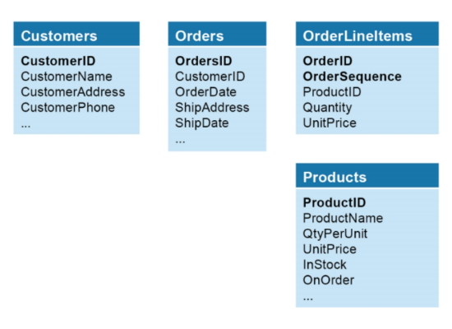



Customers:

CustomerID is Primary Key

Orders:

OrdersID is Primary Key

CusotmerID is Foreign Key to Customers Table

OrderLineItems:

OrderID and OrederSequence are composite Primary Keys

ProductID is Foreign Key to Products Table.

OrderID is Foreign Key to Orders Table.

Products:

ProductID is Primary Key